Chapter 6: JavaScript
Introduction
- JavaScript: It is a programming language used for web applications.
- Its code is written within an HTML program, hence saved with extension .html
- <script> tag: is used for JavaScript programs.
- document.write : This is a function used to display results of JavaScript in an HTML program. E.g. document.write(“This is my first JavaScript program”);
- To display output (result) in text form: type = “text/javascript”

Program: firstJSprogram.html
<DOCTYPE html>
<html>
<body>
<script>
type="text/javascript">
document.write(“This is my first JavaScript
program");
</script>
</body>
</html>

Arithmetic Operations
Arithmetic Operators
+ (plus): for addition
- (minus): for subtraction
* (asterisk): for multiplication
/ (slash): for division
Declaration of variables: we use the word var e.g. var A = 10;
reserves an area for variable A and puts a value 10 in it. Note: There is a semi-colon after JavaScript statement.

Example – Addition
Write a program which adds 2 numbers A and B having values 10 and 15 respectively and get the sum in C.
<!DOCTYPE html>
<html>
<body>
<script>
var A=10;
var B=15;
var C=A+B;
document.write("The Total = "+C);
</script>
</body>
</html>

Creating Forms
- A "form" on a website is a section of a webpage that allows users to input information, typically by filling in fields like their name, email address, or other details
- Form is then submitted to the website owner to collect data or process a request
- Examples: Forms for jobs, admissions, contacting customer service etc.
- It is essentially an interactive tool for gathering user information directly on the website

Creating Forms – Example Program
<!DOCTYPE html>
<html>
<body>
<h2>Application Form for job of Web Engineer</h2>
<form>
<label for="fname">First name:</label><br>
<input type="text" id="fname" name="fname" value=""><br>
<label for="lname">Last name:</label><br>
<input type="text" id="lname" name="lname" value="">
</form>
</body>
</html>

Components of the Form
- To create a form, we use <form> element and where form is complete, it is closed </form>
- <label> element is the title (heading) of a field e.g. First name, Last name
- <br> (break) element: to go to next line
- input type="text“: input statement used when we have to enter text (alpha-numeric) data
- id="fname" name="fname“: reserves an area “fname” for first name in memory
- value=“”: sets a null value
- id="lname" name="lname“: reserves an area “lname” for last name in memory
- Submit button: used to save data in a database
- Update button: used to edit the data entered in the form
- Home button: takes us to the home page of the website
- (Note: We will see how to create these buttons later on)

JavaScript Comments
- We can use any comments for our understanding by using //
- Comments are not executable i.e. they do not display output
- E.g. // My first JavaScript program

Creating Button “Submit”
<!DOCTYPE html>
<html>
<body>
<button
type="button" id=“sbmtBtn" onclick=“sbmtFunction()">Submit
</button>
<script>
function sbmtFunction()
{
var x = document.getElementById(“sbmtBtn");
// Store data in a database on server – will be discussed later
}
</script>
</body></html>

Components of the Button
type="button" id=“sbmtBtn" onclick=“sbmtFunction()">Submit
- “button” element is defined by type="button“, which will create a button
- A variable sbmtBtn is used to create a button in computer’s memory by id=“sbmtBtn“
- onclick=“sbmtFunction()>Submit: calls a function sbmtFunction() to take an action and also labels the button as Submit
function sbmtFunction()
- This is a JavaScript function which helps us to create the button
- This function is called in the above HTML program
- In this function
- var x = document.getElementById(“sbmtBtn");
- reserves an area x in memory for the function
- sbmtBtn must be the same as given in the id of HTML program

Combining Form with Button
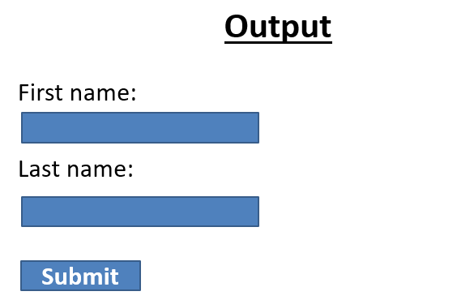
<!DOCTYPE html>
<html>
<body>
<h2>Application Form for job of Web Engineer</h2>
<form>
<label for="fname">First name:</label><br>
<input type="text" id="fname" name="fname" value=""><br>
<label for="lname">Last name:</label><br>
<input type="text" id="lname" name="lname" value="">
<button
type="button" id=“sbmtBtn" onclick=“sbmtFunction()">Submit
</button>
<script>
function sbmtFunction()
{
var x = document.getElementById(“sbmtBtn");
// Store data in a database on server – will be discussed later
}
</script>
</form>
</body>
</html>
Chapter 7: Server-side Technologies & Web APIs
Server-side Technologies
- Server-side code can be written in any number of programming languages
- Examples: JavaScript, PHP, Python, C# and NodeJS (JavaScript already discussed)

Example – C# Program
using System;
namespace HelloWorld
{
class Program
{
static void Main(string[] args)
{
Console.WriteLine(“I am a C# program!");
}
}
}
Output
I am a C# program!

Node.JS
console.log(‘Invalid Password');
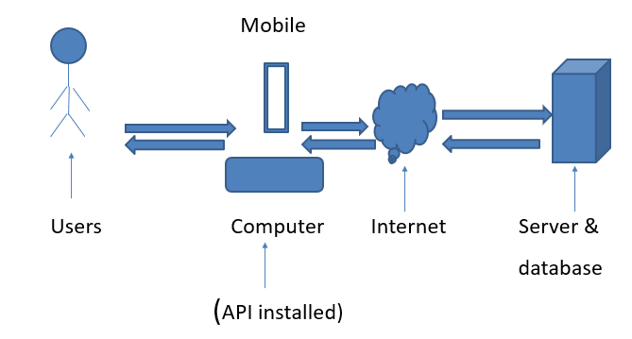
console.log(‘Try again');
Output
(The following result is displayed by an operating system)
Invalid Password
Try again

Application Programming Interface (API)
- It is a software which allows communication between two software
- API consists of protocols and definitions
- APIs help us to access the features or data of another application.

Web API
- It is an application programming interface for the Web.
- Web API connects web browser and web server with other software or data which help us to develop web applications.
- It provides extra features which help us in web development.
- Web API extends the functionality of a web browser and web server.

Types of web APIs
- Public
- Partner
- Internal (Private)
- Composite

Public (Open or External) APIs
- A Public API is open and available for use by any outside developer or business.
- An enterprise that promotes a business strategy that involves sharing its applications and data uses a public API.

Partner APIs
- A partner API is only available to specifically selected and authorized outside developers.
- Used for business-to-business activities.
- E.g. Telenor wants to verify data of some of their customers with NADRA to check legal SIMS.
- There must be a legal contract between the two parties.

Internal (Private) APIs
- An internal (Private API) is intended only for use within the enterprise to connect systems and data.
- E.g. In an organization, the employees data is shared by Human Resources (HR) and Account departments.

Composite APIs
- These are generally combination of two or more APIs.
- E.g. two companies ABC and XYZ share their data with one another
- Also ABC interchanges data among HR and Accounts departments.
- XYZ also shares data among HR and Accounts departments.
Field
- A data item stored in computer’s memory or in a web server
- Examples: Emp ID, Emp Name, Designation

Record (Row)
- It is a combination of a number of fields.
Example:
Emp ID Emp Name Designation Fields (Columns)
017 Arshad Officer Record (Row)

Data File (Table)
- Combination of Records
- Example 1: Employee File (EMP)
Emp ID Emp Name Designation Fields (Columns)
017 Arshad Officer Record 1
018 Hasan Programmer Record 2
- Each data file consists of a field with which we
can easily access each record called the
Key Field (Primary Key).
- In this file EMP_ID is the Key Field.
- Key Field must be the first field in a data file.

Example 2: Department File (DEPT)
Dept Code Dept Name Location ID Fields (Columns)
001 Admin Karachi Record 1
002 IT Lahore Record 2

Database It is a collection of a number of Files.
Data First Approach with Web APIs
- As said earlier “Web API connects web browser and web server with other software or data which help us to develop web applications”.
- Example: If a database is created and stored on a web server, it can easily be accessed on a web browser with the help of web API
- If we want to receive a database to a web browser from a web server, web API is necessary.
- But web API is not same for all types of databases.
- We have to configure web API according to each specific database, after which we can see it properly on our web browser.
- This means we have to first create our database properly, then configure web API according to our database
- That is why, it is called Data First Approach with Web APIs.

Entity Data Model XML (EDMX): To configure web API according to our database, a software is used called Entity Data Model XML (EDMX).

Example
Key Field must be the first field in a data file.
A file in our database is:
Emp ID Emp Name Designation Fields (Columns)
017 Arshad Officer Record 1
018 Hasan Programmer Record 2
But we create file as follows:
Emp Name Emp_ID Designation Fields (Columns)
Arshad 017 Officer Record 1
Hasan 018 Programmer Record 2
First we have to convert this file as given above having EMP_ID as the first field, then by using EDMX we can configure web API for this database.
This is Data First Approach with Web APIs

Chapter 8 Model View Framework / Model View Controller (MVC)
Introduction to MVC
- The MVC framework (architecture/pattern) is a popular software design methodology to build web applications.
- It is very successful for any online businesses.
- MVC helps us to build complex web applications easily and smoothly as compare to other approaches.
- Makes a web application more user-friendly.
- Makes web design changes easier.

Parts of MVC
- MVC stands for Model-View-Controller because it consists of 3 parts: Model, View, Controller
- All these parts consists of programs written in web development languages HTML, CSS, JavaScript, PHP etc.
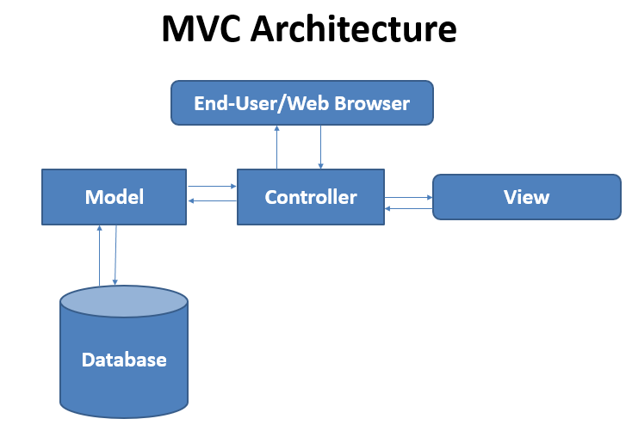
Model
- It handles the data used by your web application
- E.g. if we create a database of an online form
- new data in it is inserted (added), existing data can be updated (edited), irrelevant data can be deleted (removed)
- queries can be handled like searching a specific record

View
- It is a user interface, which displays the data provided by the model, hence user can see it.
- The view uses
- HTML code to show data contents
- CSS to display data in formatted style
- JavaScript code that provides functions like form validation or drag-and-drop facilities etc.

Controller
- It is an interface between the end-user and other parts of MVC i.e. Model and View.
- If end-user wants some data from a database, he/she requests to the Controller, which receives it through the Model.
- To see that data on web browser, the end-user requests the Controller, which request View to show that data.

Chapter 9 Web Application Security

Web Application Security – Definition
- It is the practice of protecting websites, web applications, and APIs from attacks.
- The ultimate aims of Web Application Security are
- keeping web applications functioning smoothly
- protecting business from cyber vandalism, data theft, unethical competition, and other negative consequences
- Due to vast use of the internet, there is always a danger of cyber attacks on web applications from different directions.
- Therefore it is important to secure our web application from these attacks.

Common Web Application Security Risks
- Zero-day vulnerabilities (weaknesses)
- Cross site scripting (XSS)
- SQL injection (SQLi)
- Bots

Zero-day vulnerabilities (weaknesses)
- These are unknown and new to a web developer and, and can attack any time on your web application.
- There are around 20,000 such attacks every year throughout the world.
- It is not possible to fix such problems except to clear web application from the server and restore it from the backup.

Cross site scripting (XSS)
- XSS is a vulnerability that allows an attacker to enter into a web application to access important information directly.
- The attacker injects a malicious code through the web browser and when the website is run that code transmits the website information to somewhere else through the internet.
- To prevent XSS attacks, don’t open suspicious emails and messages. Also be careful to receive unknown messages from emails & calls and messages from social media. Web security department can help such problems.
SQL injection (SQLi)
- SQLi is a method by which a hacker attacks a database, while user is executing a search query.
- Attackers access to unauthorized information, create new user permissions, or manipulate or destroy sensitive data.
- To prevent such attacks, only authorized users should be allowed to use SQL databases and their user-ids and passwords must be changed regularly.

Bots
- Computer bots and internet bots are essentially digital tools and, like any tool, can be used for both good and bad.
- Good bots carry out useful tasks, however, bad bots – also known as malware bots – carry risk and can be used for hacking to steal or corrupt programs or data.
- Bots are entered inside a web application through input devices (using web browsers).
- For this, web security departments should keep an eye on website users.

